17.125: The rate at which heat is aborbed at the blackened end is the heat current in the rod,
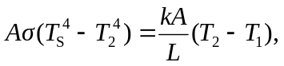
where 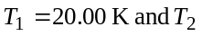 is the temperature of the blackened end of the rod. If this were to be solved exactly, the equation would be a quartic, very likely not worth the trouble. Following the hint, approximate 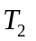on the left side of the above expression as T₁ to obtain
This approximation for 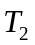is indeed only slightly than 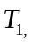 and is a good estimate of the temperature. Using this for 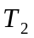in the original expression to find a better value of 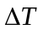 gives the same to eight figures, and further, and further iterations are not worth –while.

A numerical program used to find roots of the quartic equation returns a value for that differed from that found above in the eighth place; this, of course, is more precision than is warranted in this problem.

